**ПРИЛОЖЕНИЕ А**

**Программный код файлов:**

**1.index.html**

<!DOCTYPE html>

<html lang="en">

<head>

<meta charset="UTF-8" />

<meta http-equiv="X-UA-Compatible" content="IE=edge" />

<meta name="viewport" content="width=device-width, initial-scale=1.0" />

<link rel="stylesheet" href="/css/normalize.css" />

<link rel="stylesheet" href="/css/blocks/header.css" />

<link rel="stylesheet" href="/css/blocks/main.css" />

<link rel="stylesheet" href="/css/fonts/fonts.css" />

<link rel="stylesheet" href="/css/fonts/Karla/stylesheet.css" />

<link rel="stylesheet" href=/css/blocks/story.css />

<link rel="stylesheet" href=/css/blocks/base.css />

<link rel="stylesheet" href="/css/blocks/featured_mugs.css" />

<link rel="stylesheet" href="/css/blocks/story.css" />

<link rel="stylesheet" href="/css/blocks/moreProducts.css" />

<link rel="stylesheet" href="/css/blocks/premiumOffer.css" />

<link rel="stylesheet" href="/css/blocks/stories.css" />

<link rel="stylesheet" href="/css/blocks/contacts.css" />

<link rel="stylesheet" href="/css/blocks/footer.css" />

<title>Coffee Style</title>

</head>

<body class="body">

<header class="header">

<div class="coffeeStyle">

<a href="#"><img src="/images/logo.png" alt="logo" /></a>

</div>

<div class="home">HOME</div>

<div class="products">OUR PRODUCTS</div>

<div class="blog">BLOG</div>

<div class="about">ABOUT</div>

<div class="contact">CONTACT</div>

<div class="styleGuide">STYLE GUIDE</div>

<div class="cart">

<div class="paket"><img src="/images/paket.png" alt="" /></div>

<div class="cartButton">CART</div>

<div class="round"><div class="count">0</div></div>

<div class="line"></div>

</div>

</header>

<div class="main">

<div class="background">

<div class="mug_back"><img src="/images/mug_back.png" alt="" /></div>

</div>

<div class="main_text">

<div class="main_text1">Best place to buy design</div>

<div class="main_text2">Coffee Mugs</div>

<div class="main_text3">

The most verstile furniture system ever created. Designed to fit your

life, made to move and grow

</div>

<div class="main_text4">Explore our products</div>

</div>

</div>

<div class="story">

<div class="story_header">

<h3>

Even the all-powerful Pointing has no control about the blind texts.

</h3>

</div>

<div class="story_text">

<p>

It is a paradisematic country, in which roasted parts of sentences fly

into your mouth. Even the all-powerful Pointing has no control about

the blind texts it is an almost unorthographic life One day however a

small line of blind text by the name of Lorem Ipsum decided to leave

for the far World of Grammar.

</p>

</div>

<div class="fullStory">Read the full Story</div>

<div class="story_line"></div>

</div>

<div class="featuredMugs">

<div class="fmugs_header_container">

<div class="fmugs_line1"></div>

<div class="fmugs_header">Fearured Mugs</div>

<div class="fmugs_line2"></div>

</div>

<div class="fMugs_containers">

<div class="container1">

<img src="/images/mug1.png" alt="" class="img_mug1" />

<p class="ppc_mug">Pink Premium Ceramic</p>

<span class="price1">$ 99.00 USD</span>

</div>

<div class="container2">

<img src="/images/mug2.png" alt="" class="img_mug2" />

<p class="gd_mug">Golden Designers Mug</p>

<span class="price2">$50.00</span

><span class="sale">$ 69.00 USD</span>

</div>

</div>

</div>

<div class="moreProducts">

<div class="moreProducts_header">

<div class="moreProducts_line1"></div>

<p class="mp_head">More Products</p>

<div class="moreProducts_line2"></div>

</div>

<div class="products1">

<div class="product_1">

<img class="moreProducts_img" src="/images/mug3.png" alt="" />

<p class="product_name">Red Love Cup</p>

<span class="price2">$25.00</span

><span class="sale">$ 37.00 USD</span>

</div>

<div class="product_2">

<img class="moreProducts_img" src="/images/mug4.png" alt="" />

<p class="product_name">Black Tea Cup</p>

<span class="price2">$15.00</span

><span class="sale">$ 29.00 USD</span>

</div>

<div class="product_3">

<img class="moreProducts_img" src="/images/mug5.png" alt="" />

<p class="product_name">B&W Essentials Mug</p>

<span class="price1">$19.00 USD</span>

</div>

</div>

<div class="products2">

<div class="product_4">

<img

class="moreProducts_img"

src="/images/winterStyleMug.png"

alt=""

/>

<p class="product_name">Winter Style Mug</p>

<span class="price1">$25.00 USD</span>

</div>

<div class="product_5">

<img class="moreProducts_img" src="/images/ceramicTea.png" alt="" />

<p class="product_name">Ceramic Tea Cup</p>

<span class="price1">$15.00 USD</span>

</div>

<div class="product_6">

<img

class="moreProducts_img"

src="/images/nohandleBarCup.png"

alt=""

/>

<p class="product_name">No Handle Bar Cup</p>

<span class="price1">$34.00 USD</span>

</div>

</div>

<div class="products3">

<div class="product_7">

<img

class="moreProducts_img"

src="/images/espressoCupbyMugs.png"

alt=""

/>

<p class="product_name">Espresso Cup by Mug.co</p>

<span class="price1">$25.00 USD</span>

</div>

<div class="product_8">

<img

class="moreProducts_img"

src="/images/pinkPremiumCeramic.png"

alt=""

/>

<p class="product_name">Pink Premium Ceramic</p>

<span class="price1">$99.00 USD</span>

</div>

<div class="product_9">

<img

class="moreProducts_img"

src="/images/summerDesignerCup.png"

alt=""

/>

<p class="product_name">No Handle Bar Cup</p>

<span class="price1">$29.00 USD</span>

</div>

</div>

</div>

<div class="premiumOffer">

<div class="premOffer_head">

<div class="premOffer_line1"></div>

<p class="premOffer_header">

Buy 2 mugs and get a coffee magazine free

</p>

<div class="premOffer_line2"></div>

</div>

<div class="premOffer_main">

<div class="premOffer_images">

<div class="premOffer_block_image1">

<img src="/images/book.png" alt="" />

</div>

<div class="premOffer_block_image2">

<div class="premOffer_image1">

<img src="/images/cup1.png" alt="" />

</div>

<div class="premOffer_image2">

<img src="/images/cup2.png" alt="" />

</div>

</div>

</div>

<div class="premOffer_text">

<p class="premOffer_text1">Premium Offer</p>

<p class="premOffer_text2">Get our Coffee Magazine</p>

<p class="premOffer_text3">

The most versatile furniture system ever created. Designed to fit your life.

</p>

<p>

<button class="premOffer_button">Start Shopping</button>

</p>

</div>

</div>

<img src="/images/background2.png" alt="" class="photo" />

</div>

<div class="stories">

<div class="stories_head">

<div class="stories_line1"></div>

<p class="stories_header">Behind the mugs, lifestyle stories</p>

<div class="stories_line2"></div>

</div>

<div class="stories_main">

<div class="stories_1">

<img src="/images/photo1.png" alt="" />

<p class="stories_text1">

Health Check: why do I get a headache when I haven’t had my coffee?

</p>

<p class="stories_text2">

It is a paradisematic country, in which roasted parts of sentences

fly into your mouth.

</p>

<p class="stories_text3">October 9, 2018</p>

</div>

<div class="stories_2">

<img src="/images/photo2.png" alt="" />

<p class="stories_text1">

How long does a cup of coffee keep you awake?

</p>

<p class="stories_text2">

It is a paradisematic country, in which roasted parts. Vel qui et ad

voluptatem.

</p>

<p class="stories_text3">October 9, 2018</p>

</div>

<div class="stories_3">

<img src="/images/photo3.png" alt="" />

<p class="stories_text1">

Recent research suggests that heavy coffee drinkers may reap health

benefits.

</p>

<p class="stories_text2">

It is a paradisematic country, in which roasted parts of sentences

fly into your mouth.

</p>

<p class="stories_text3">October 9, 2018</p>

</div>

</div>

</div>

<div class="signUp">

<div class="signUp_head">

<div class="signUp_line1"></div>

<div class="signUp_header">Sign up and get free coffee bags</div>

<div class="signUp_line2"></div>

</div>

<div class="signUp_main">

<p class="coffee_updates">Coffee updates</p>

<div class="signUp_form">

<form class="signUp_form1">

<p>

<input

class="signUp_emailInput"

type="email"

placeholder="customer@coffestyle.io"

/>

</p>

</form>

<form class="signUp_form2">

<p>

<input class="signUp_button" type="submit" value="Subscribe" />

</p>

</form>

</div>

</div>

</div>

<footer class="footer">

<div class="footer_container">

<div class="item footer_item1">

<img src="/images/logo.png" alt="" />

</div>

<div class="item footer_item2">Menu</div>

<div class="item footer_item3">Follow Us</div>

<div class="item footer_item4">Contact Us</div>

<div class="item footer_item5">

Delivering the best coffee life since 1996. From coffee geeks to the

real ones.

</div>

<div class="item footer_item6">Home</div>

<div class="item footer_item7">Facebook</div>

<div class="item footer_item8">We’re Always Happy to Help</div>

<div class="item footer_item9">Our Products</div>

<div class="item footer_item10">Instagram</div>

<div class="item footer_item11">us@coffeestyle.io</div>

<div class="item footer_item12">About</div>

<div class="item footer_item13">Pinterest</div>

<div class="item footer_item14">Contact</div>

<div class="item footer_item15">Twitter</div>

<div class="item footer_item16">CoffeeStyle Inc. © 1996</div>

<div class="item footer_item17">Styleguide</div>

<div class="item footer_item18">Powered by Webflow</div>

</div>

</footer>

</body>

</html>

**ПРИЛОЖЕНИЕ Б**

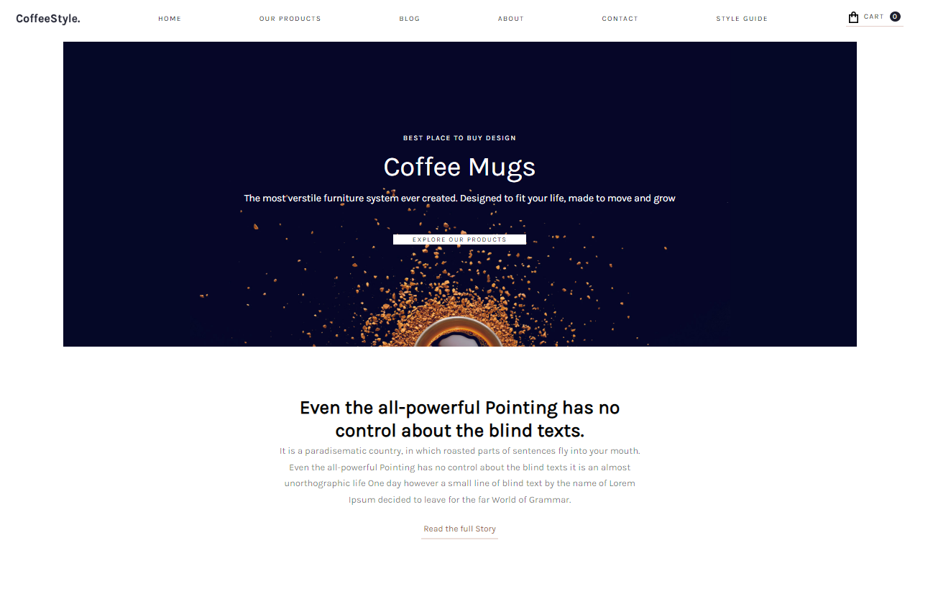**Отображение сайта в браузере**

Рисунок 2 — Скриншот с браузера 1

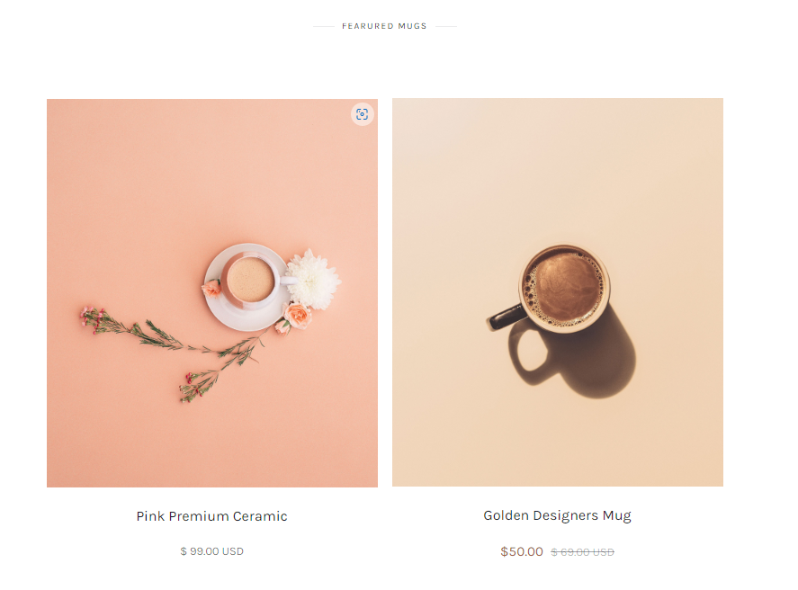

Рисунок 3 — Скриншот с браузера 2

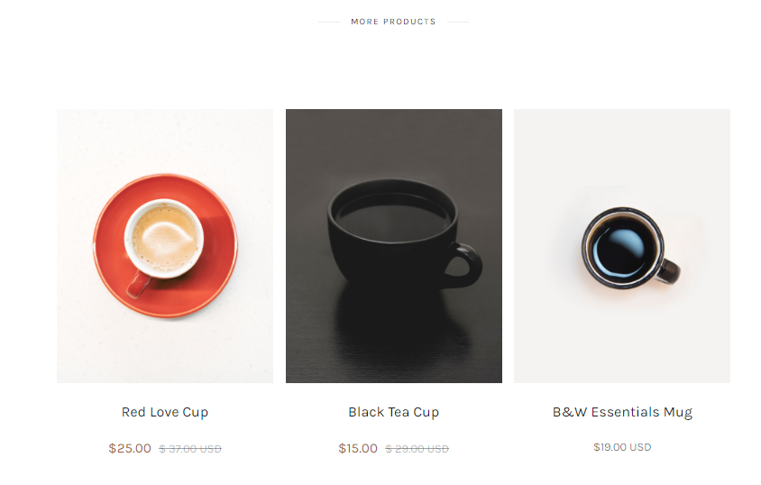

Рисунок 4 — Скриншот с браузера 3

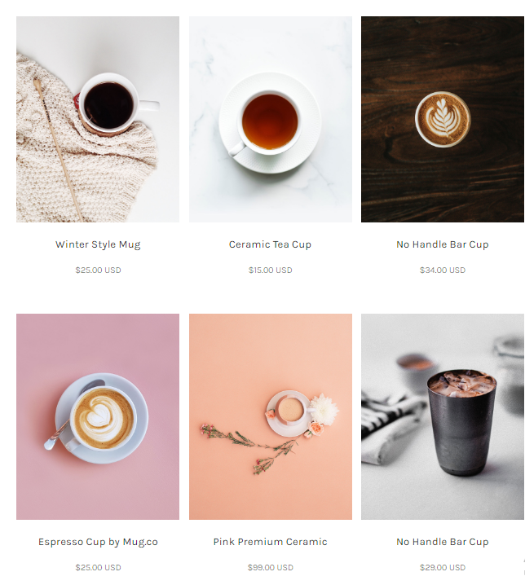

Рисунок 5 — Скриншот с браузера 4

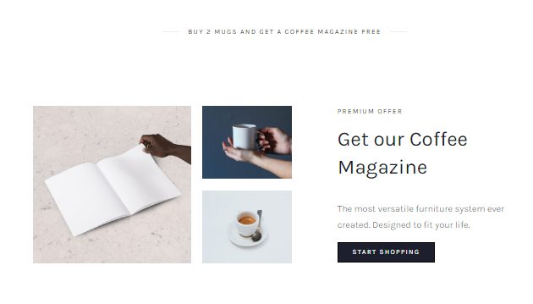

Рисунок 6 — Скриншот с браузера 5

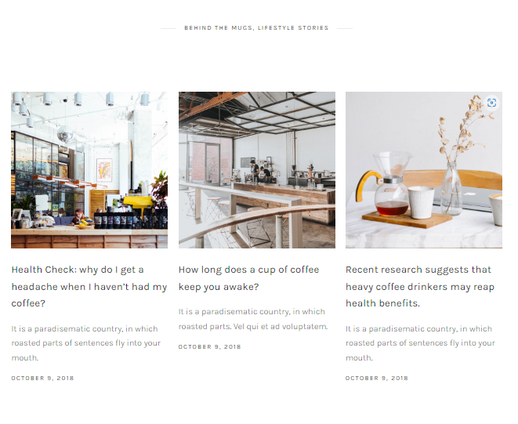

Рисунок 7 — Скриншот с браузера 6



Рисунок 8 — Скриншот с браузера 7

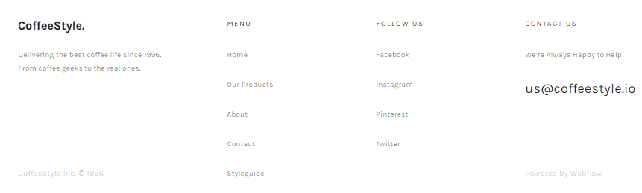

Рисунок 9 — Скриншот с браузера 8

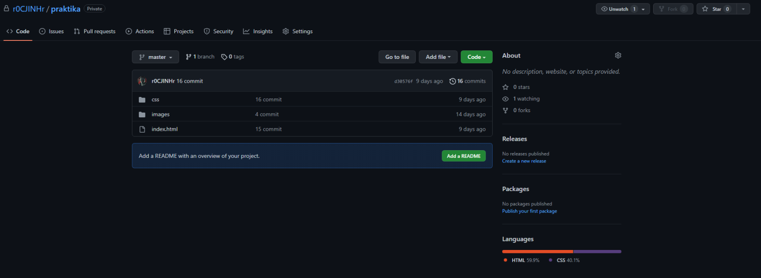

Рисунок 10 — Репозиторий в Github

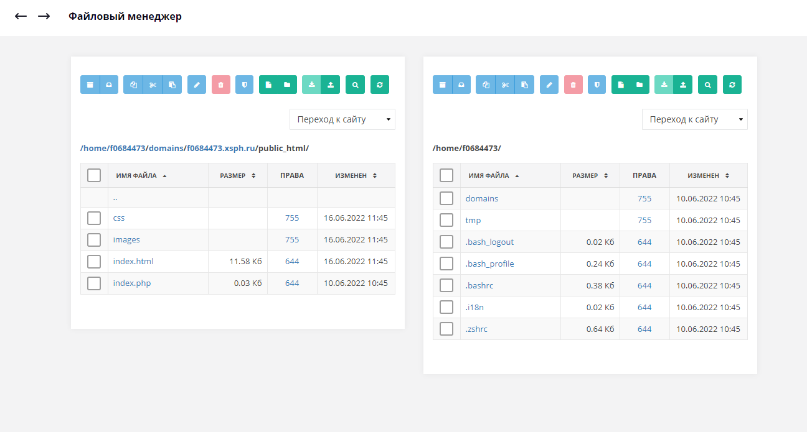

Рисунок 11 — Файловый менеджер

**ПРИЛОЖЕНИЕ В**

